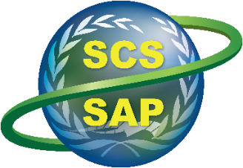
Implementing the Strategic Action Programme for the South China Sea and Gulf of Thailand (SCS SAP Project)

Second Meeting of the Regional Working Group on Land-Based Pollution

11-12 November 2024, Shenzhen, China

PROVISIONAL LIST OF PARTICIPANTS

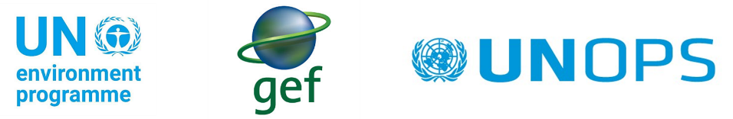

REGIONAL WORKING GROUP ON LAND - BASED POLLUTION MEMBERS

NATIONAL FOCAL POINTS AND REPRESENTATIVES
Cambodia  Mr. Than Monomoyith  Deputy Chief Office, Department Coastal Zone  and Marine Conservation, Ministry of Environment  Email: monomoyith84@gmail.com  Mr. Him Chandath  Acting Director of Water Quality  Management Department, Ministry of Environment  Email: him.chandath@moe.gov.kh |  | Philippines  Ms. Amy Lecciones  Executive Director and Vice-President  Society for the Conservation of Philippine Wetlands  Email: amy_lecciones@yahoo.com  Dr. Michael Angelo B. Promentilla  Professor  De La Salle University  Email: michael.promentilla@dlsu.edu.ph
China  Dr. Yu Yunjun  Senior Engineer  South China Institute of Environmental Sciences  Ministry of Ecology and Environment  Email: yuyunjun@scies.org  Dr. Zhao Xiao  Senior Engineer  South China Institute of Environmental Sciences, Ministry of Ecology and Environment  Email: zhaoxiao@scies.org |  | Thailand  Dr. Wilawan Thanatemaneerat  Environmentalist Senior Professional Level  Pollution Control Department, Ministry of Natural  Resources and Environment  Email: aristrotle@gmail.com  Ms. Atiporn Weraarchakul  Environmentalist  Pollution Control Department, Ministry of Natural  Resources and Environment  Email: atiporn70@gmail.com
Indonesia  Mr. Fahmi Octavialdo  Environmental Impact Control Officer  Directorate of Coastal and Marine Pollution and  Degradation Control, Ministry of Environmental and Forestry  Email: fahmioctavialdo@gmail.com  Dr. Ario Damar  Professor  Department of Aquatic Resource Management  Faculty of Fisheries and Marine Sciences  Center for Coastal and Marine Resources Studies Bogor Agricultural University  Email: adamar@apps.ipb.ac.id |  | Vietnam  Dr. Pham Van Loi  Deputy Director General  Viet Nam Environmental and Marine Sciences Institute, Ministry of Natural Resources and Environment  Email: loipv111965@gmail.com  Ms. Nguyen Le Vinh  Head, Sciences and International Cooperation Department, Viet Nam Environmental and Marine Sciences Institute, Ministry of Natural Resources and Environment  Email: nguyenlevinh255@gmail.com
REGIONAL EXPERTS |  | PROJECT COORDINATION UNIT
Dr. Gil Jacinto  Retired Professor, Marine Science Institute  University of the Philippines  Email: gjacinto@gmail.com |  | Dr. Vo Si Tuan  Regional Science Coordinator  SCS SAP Project  Email: situanv@unops.org
SCS SAP PROJECT NATIONAL COORDINATORS

Cambodia  Mr. Sopheak Thav  Programme Management Specialist-National Coordinator, SCS SAP Project  Email: sopheakt@unops.org |  | Philippines  Mr. Romeo Trono  Programme Management Specialist-National Coordinator, SCS SAP Project  Email: romeot@unops.org
China  Dr. Pei Xiangbin  Programme Management Specialist-National Coordinator, SCS SAP Project  Email: xiangbinp@unops.org |  | Thailand  Ms. Suwimol Sereepaowong  Programme Management Specialist-National Coordinator, SCS SAP Project  Email: suwimols@unops.org
Indonesia  Mr. Heru Koesworo  Programme Management Specialist-National Coordinator, SCS SAP Project  Email: heruk@unops.org |  | Vietnam  Dr. Nguyen The Chinh  Programme Management Specialist-National Coordinator, SCS SAP Project  Email: chinhthen@unops.org

UNITED NATIONS ORGANIZATIONS AND OTHER REGIONAL ORGANIZATIONS

Coordinating Body on the Seas of East Asia (COBSEA)  Mr. Mahesh Pradhan  Coordinator  Coordinating Body on the Seas of East Asia  Ecosystems Division, United Nations Environment Programme, Bangkok, Thailand  Email: mahesh.pradhan@un.org |  | Partnerships in Environmental Management for the Seas of East Asia (PEMSEA)  Ms. Aimee Gonzales  Executive Director  Partnerships in Environmental Management for the Seas of East Asia, Quezon City, Philippines  Email: agonzales@pemsea.org

SCS SAP PROJECT COORDINATION UNIT (PCU)

Mr. Anders Poulsen  Senior Project Manager  UNEP/GEF SCS SAP Project  Email: andersp@unops.org |  | Mr. Reynaldo F. Molina  Project Management Support Specialist  UNEP/GEF SCS SAP Project  Email: reynaldom@unops.org
Ms. Ob-Orm Utthasit  Project Management Support - Senior Assistant, UNEP/GEF SCS SAP Project  Email: obormu@unops.org |  | Ms. Margarita Victoria Caballa  Project Management Specialist  UNEP/GEF SCS SAP Project  Email: margaritavi@unops.org
Dr. Liana McManus  TDA/SAP Consultant  UNEP/GEF SCS SAP Project  Email: lmcmanus57@gmail.com |  | Ms. Ratiwan Padpibool  Project Intern  UNEP/GEF SCS SAP Project  Email: ratiwan.p@pcd.go.th

